**KING FAHD UNIVERSITY OF PETROLEUM AND MINERALS**

**DEPARTMENT OF PHYSICS**

**PHYS 441-221 Particle Physics**

**Major Exam-1 Solutions**

**12/10/2022**

**NAME**

**ID #**

**Q1. (5 points)**

An electron of total energy *E* hits an electron at rest producing three electrons and one positron in the reaction

$$e+e→e+e+e+e^{+}$$

Calculate the threshold kinetic energy (minimum KE) of the incident electron for this reaction in terms of the electron mass m.

**Solution**

This problem is essentially the same as the one treated in Example 3.4 on page 106 of textbook using protons instead of electrons.

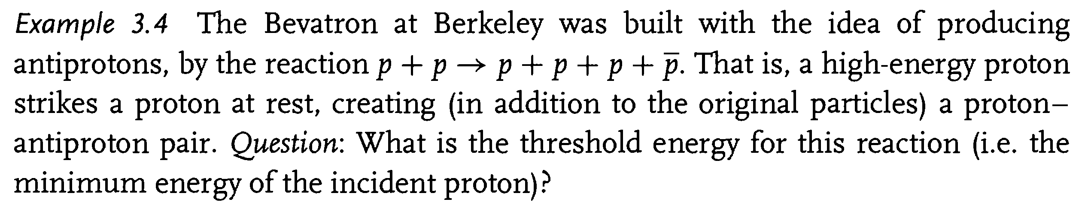

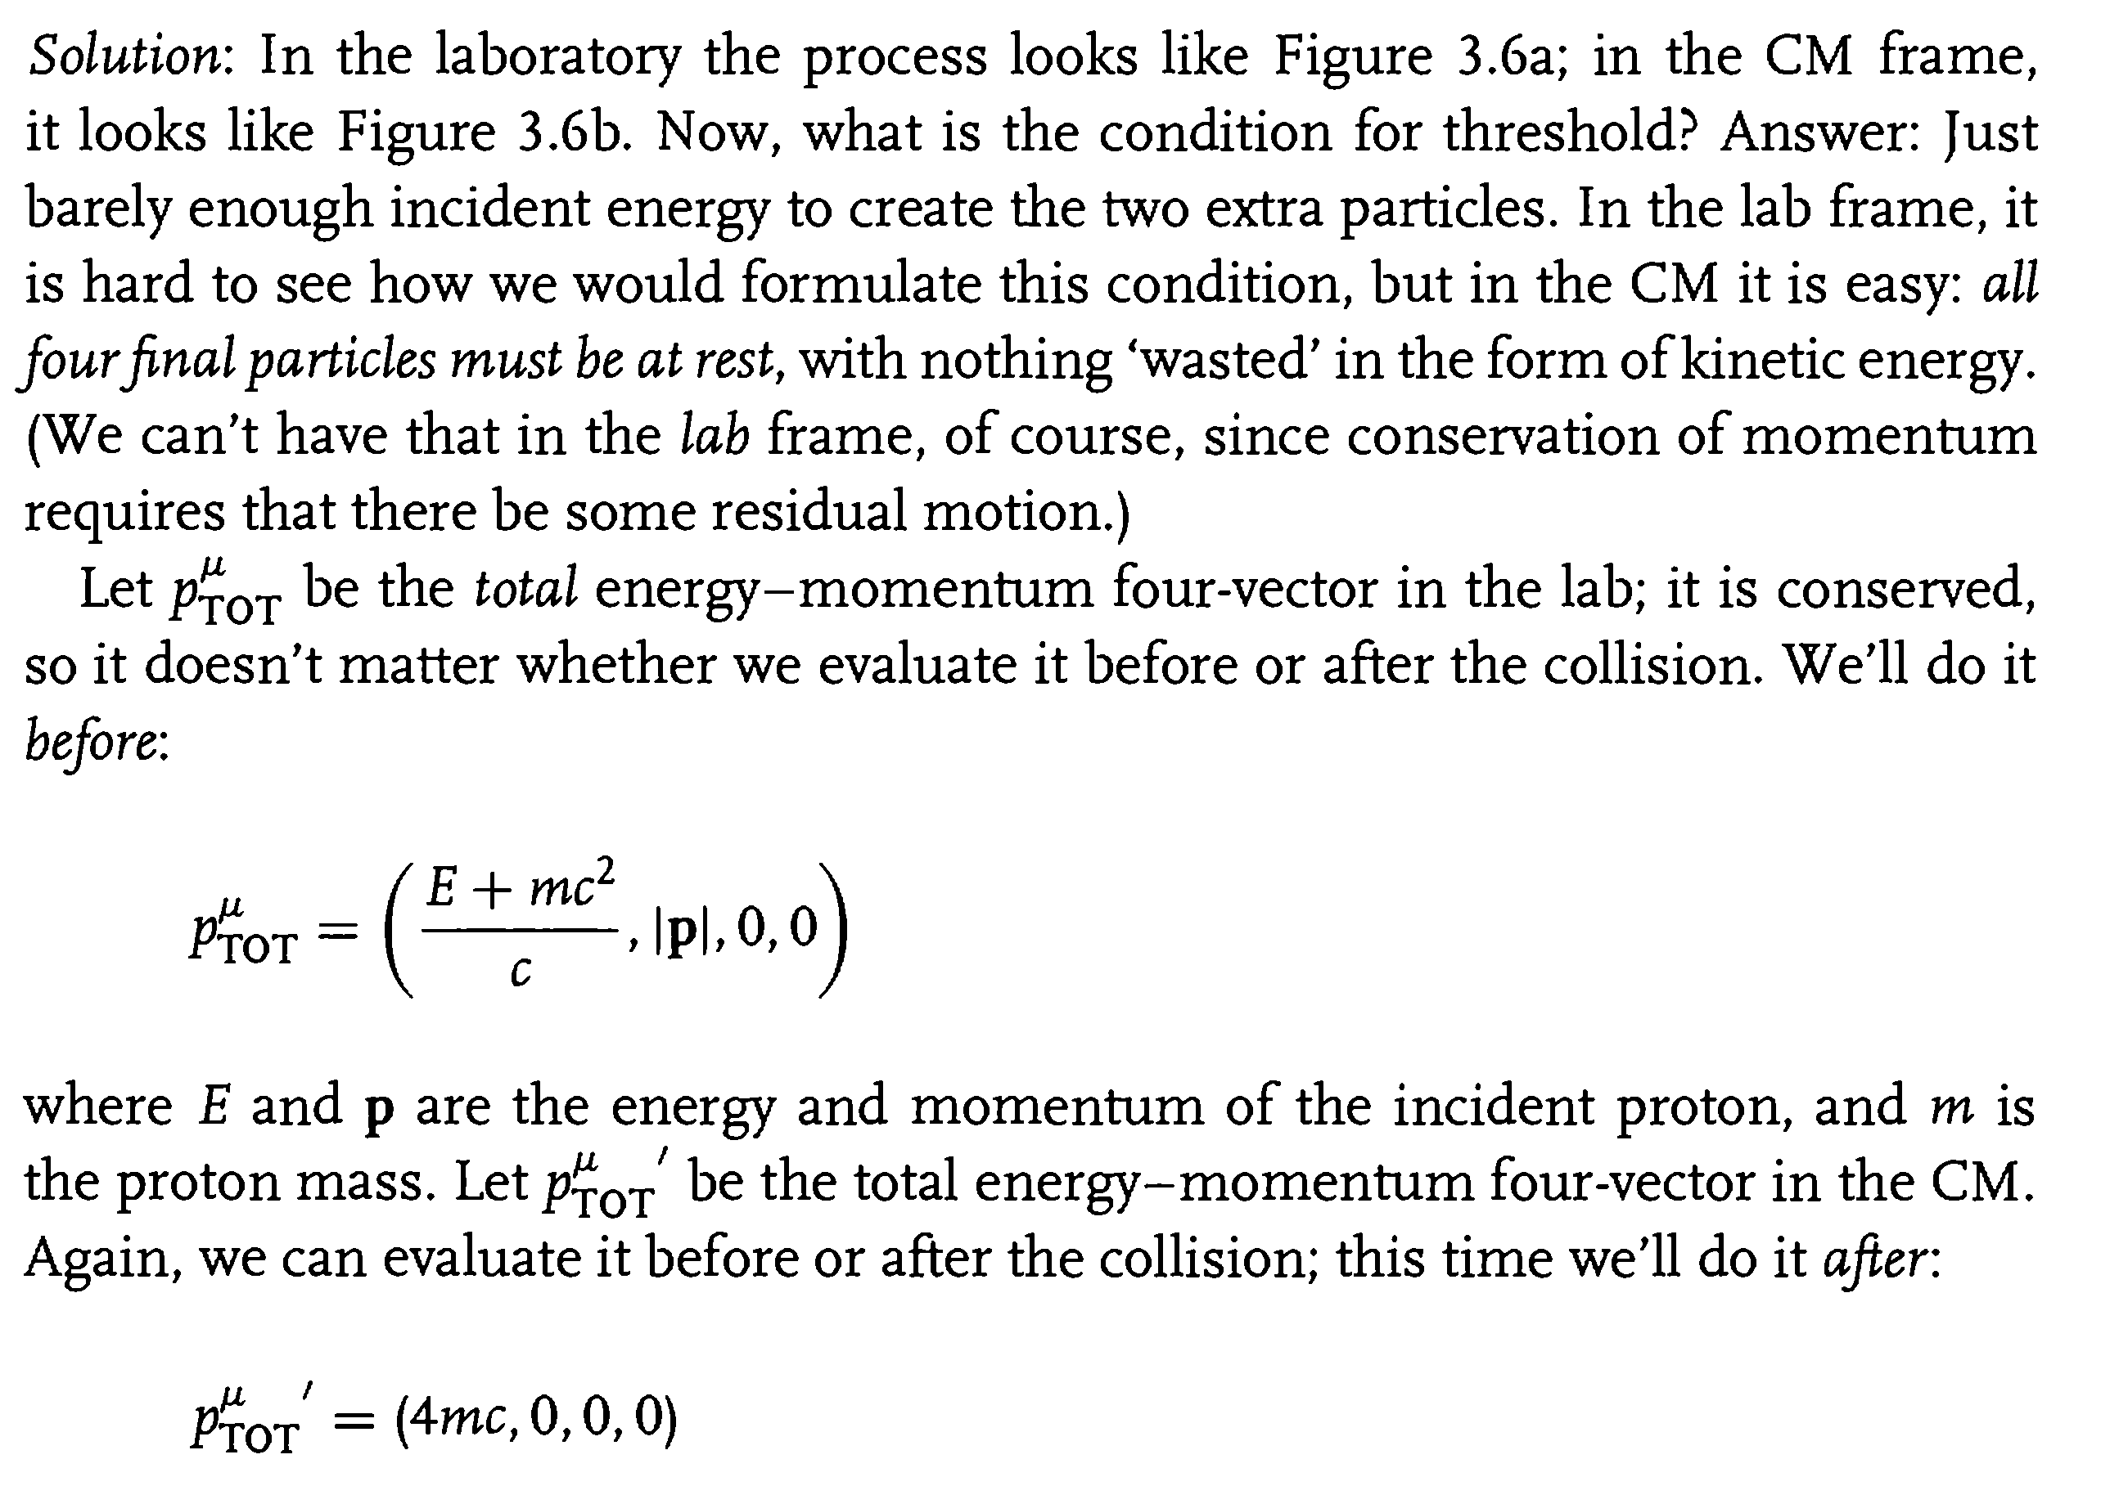

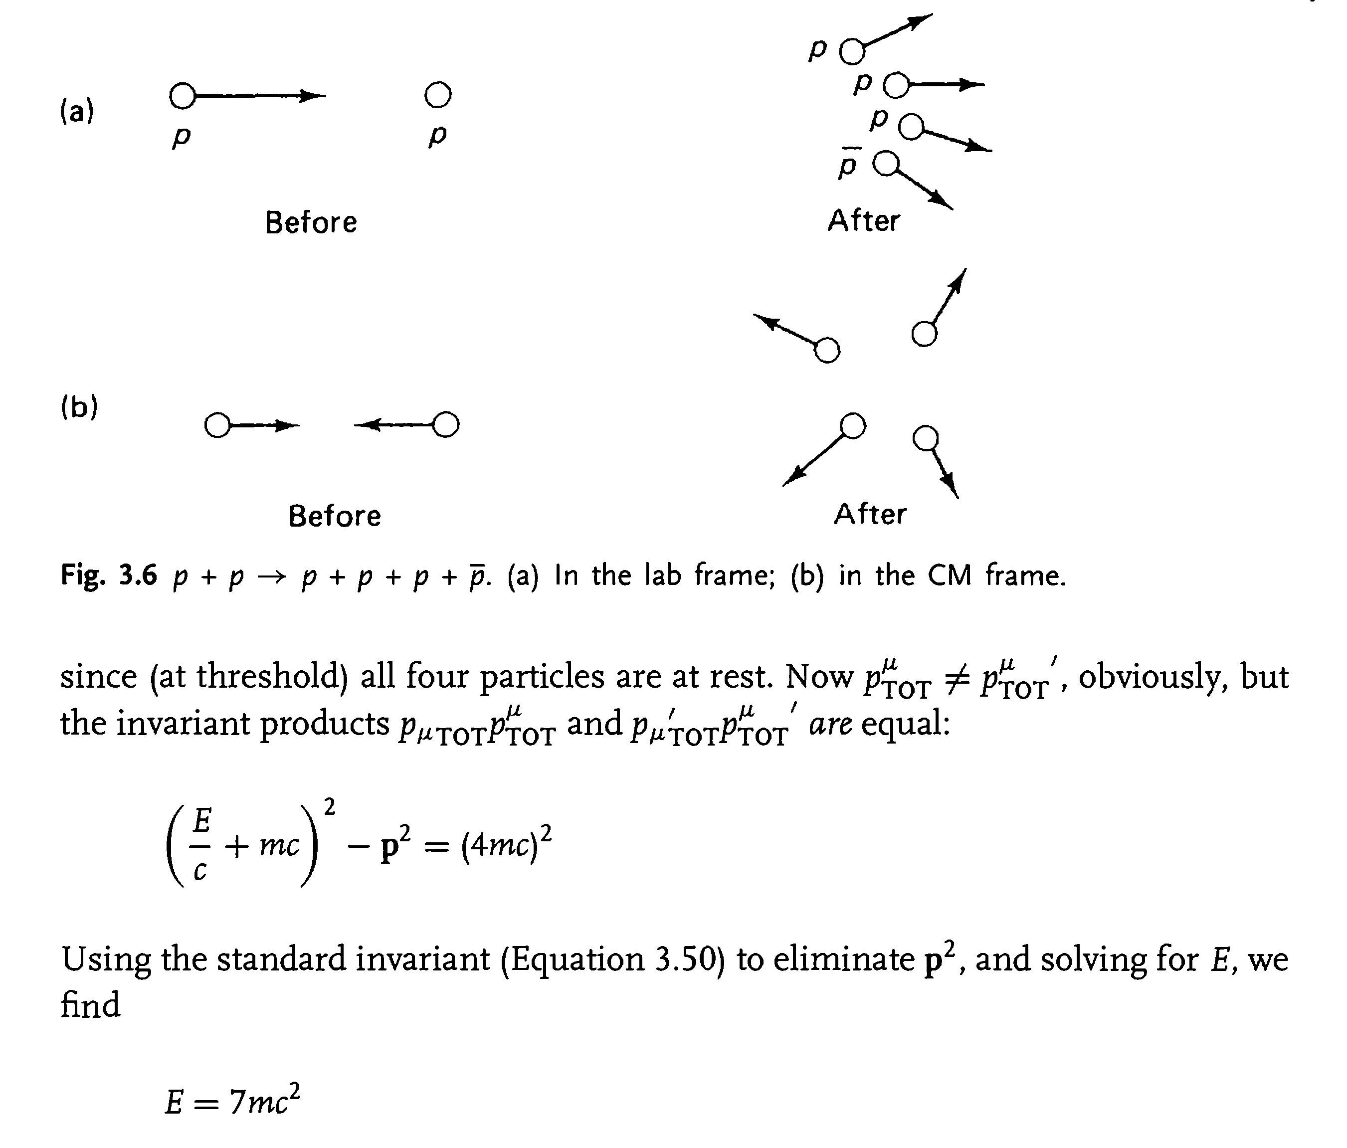

$$KE=E-mc^{2}=6 mc^{2}$$

**Q2. (5 points)**

Consider the Feynman diagram shown below for $A+A→A+A$ in the ABC toy model:



Using the Feynman rules for this model, find the scattering amplitude *M* for this diagram, assuming $m_{B}=m_{C}=0$. Leave your answer in the form of an integral over one remaining 4-momentum q.

**ADHERE TO THE MOMENTUM CONVENTION IN THE ABOVE FIGURE**

**Solution**



**Q3. (5 points)**

**(a)**Determine the lowest-order scattering amplitude for the process $A+B→A+B$. (There are two diagrams)

**(b)**Find the scattering amplitude for this process in the CM frame, assuming $m_{A}=m_{B}=m, m_{C}=0.$ Express your answer in terms of the incident energy $E$ (of particle $A$) and the scattering angle $θ$ (of particle $A$).

**Solution**









$$M=-\frac{c^{2}g^{2}}{4}(\frac{E^{2}\tan^{2}\left(\frac{θ}{2}\right)+m^{2}c^{4}}{E^{2}\left(E^{2}-m^{2}c^{4}\right)})$$